

**American International University- Bangladesh**

**COE 3103: DATA COMMUNICATION**

**Mid Lab Report 01**

**Spring 2021-2022**

**Section: Q**

**Date: 11/02/2022**

**Submitted by,**

|  |  |
| --- | --- |
| Student Name | Student Id |
| Rahman, Sheikh Talha Jubayer | 19-41468-3 |

**Tasks:**

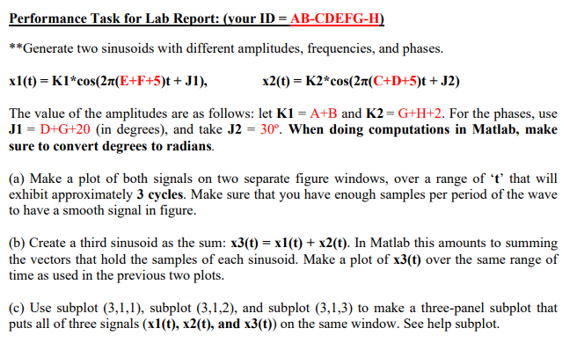

**Solution:**

%ID: 19-41468-3

A = 1;

B = 9;

C = 4;

D = 1;

E = 4;

F = 6;

G = 8;

H = 3;

K1 = A+B;

K2 = G+H+2;

J1 = deg2rad(D+G+20);

J2 = deg2rad(30);

t = 0:0.001:0.25;

x1 = K1*cos(2*pi*(E+F+5)*t+J1);

x2 = K2*cos(2*pi*(C+D+5)*t+J2);

%solution of (a)

figure

plot(t,x1) %output in figure 1

figure

plot(t,x2) %output in figure 2

%solution of (b)

x3 = x1+x2;

figure

plot(t,x3) %output in figure 3

%solution of (c)

figure

subplot(3,1,1),plot(t,x1) %output in figure 4

subplot(3,1,2),plot(t,x2) %output in figure 4

subplot(3,1,3),plot(t,x3) %output in figure 4

**Figures:**

